**Homework 2**

**16102284 Lee SungHo**

1. Analyze the pros and cons of the following principles.

FIFO (First In First Out) :

Advantage: Simple, fast, “fair” to the customer.

Disadvantages: In general, a long working time is required, and other workers wait due to inefficient work, and the work deadline and remaining work are ignored, but the efficiency is not good.

SPT (Shortest Processing Time)

Advantage: In terms of production performance, the number of orders processed within a certain period of time is the highest since the work takes the least time.

Disadvantages: Expiration due date information and long work waiting may occur. This can lead to a starvation where the process is not running due to continuous backlog of operations.

EDD (Earliest Due Date)

Advantage: Processes can be handled on a maturity date basis without taking into account process processing time, making them simple, fast and generally well-timed.

Disadvantages: High priority of past due job and it ignores work content remaining. This also can lead to a starvation

2. Consider two process models as shown below. Suppose we have one instance for each process model. Generate an optimal schedule for the completion of the processes. A schedule should also include task assignment for agents (resources).

Note that the numbers below a task indicate the time(day) takes to complete the process. For example, Reservation Request (RR) takes 1 day.

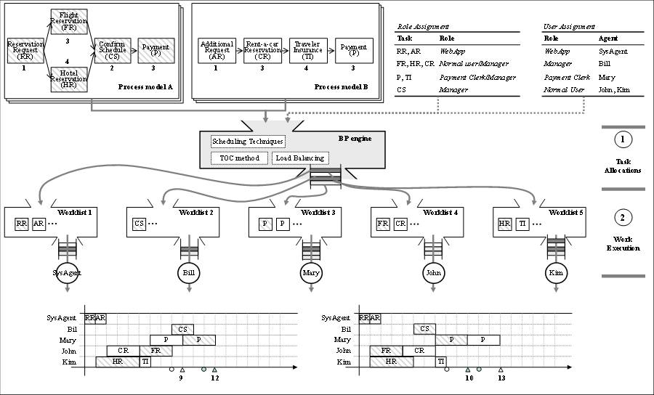

Start first Process B

|  |  |  |  |  |  |
| --- | --- | --- | --- | --- | --- |
|  | RR, AR | CS | P, TI | FR, HR, CR | FR, HR, CR |
|  | Sys | Bill | Merry | John | Kim |
| 1 | AR |  |  |  |  |
| 2 | RR |  |  | CR |  |
| 3 |  |  |  | CR | HR |
| 4 |  |  |  | CR | HR |
| 5 |  |  | TI | FR | HR |
| 6 |  |  | TI | FR | HR |
| 7 |  |  | TI | FR |  |
| 8 |  | CS | TI |  |  |
| 9 |  | CS | P |  |  |
| 10 |  |  | P |  |  |
| 11 (B Finish) |  |  | P |  |  |
| 12 |  |  | P |  |  |
| 13 |  |  | P |  |  |
| 14 (A Finish) |  |  | P |  |  |
| Total | AR -> RR | CS | TI -> P -> P | CR -> FR | HR |

Start first Process A

|  |  |  |  |  |  |
| --- | --- | --- | --- | --- | --- |
|  | RR, AR | CS | P, TI | FR, HR, CR | FR, HR, CR |
|  | Sys | Bill | Merry | John | Kim |
| 1 | RR |  |  |  |  |
| 2 | AR |  |  | FR | HR |
| 3 |  |  |  | FR | HR |
| 4 |  |  |  | FR | HR |
| 5 |  |  |  | CR | HR |
| 6 |  | CS |  | CR |  |
| 7 |  | CS |  | CR |  |
| 8 |  |  | P |  |  |
| 9 |  |  | P |  |  |
| 10 (A finish) |  |  | P |  |  |
| 11 |  |  | TI |  |  |
| 12 |  |  | TI |  |  |
| 13 |  |  | TI |  |  |
| 14 |  |  | TI |  |  |
| 15 |  |  | P |  |  |
| 16 |  |  | P |  |  |
| 17 (B finish) |  |  | P |  |  |
| Total | RR -> AR | CS | P -> TI -> P | FR -> CR | HR |

% Calculations of the two processes show that different results are produced depending on the process that was initiated. %